Marty Travis (MT) Model, the Regenerative Growth (RG) plan, and your Potential Future as a legacy farm.
This matches the "Spence Farm" (Marty Travis) philosophy: "The Relationship is the Crop."

1. The "Marty Travis" Blueprint (For Klayton)
Context: You saved Video 107 (MT Podcast) to show Klayton that farming isn't just about "Yield per Acre," but "Profit per Acre through Stewardship."
The Philosophy:
- Collaboration over Competition: Instead of Klayton fighting the Rives Bros (RG), they work together. The cows feed the corn (manure), and the corn feeds the cows (stover).
- The "Middle" Supply Chain: Moving L Cole Farms from selling "commodity corn" to potential "identity-preserved" markets (future goal).
- Legacy: Farming in a way that the soil is better in 10 years, not depleted.
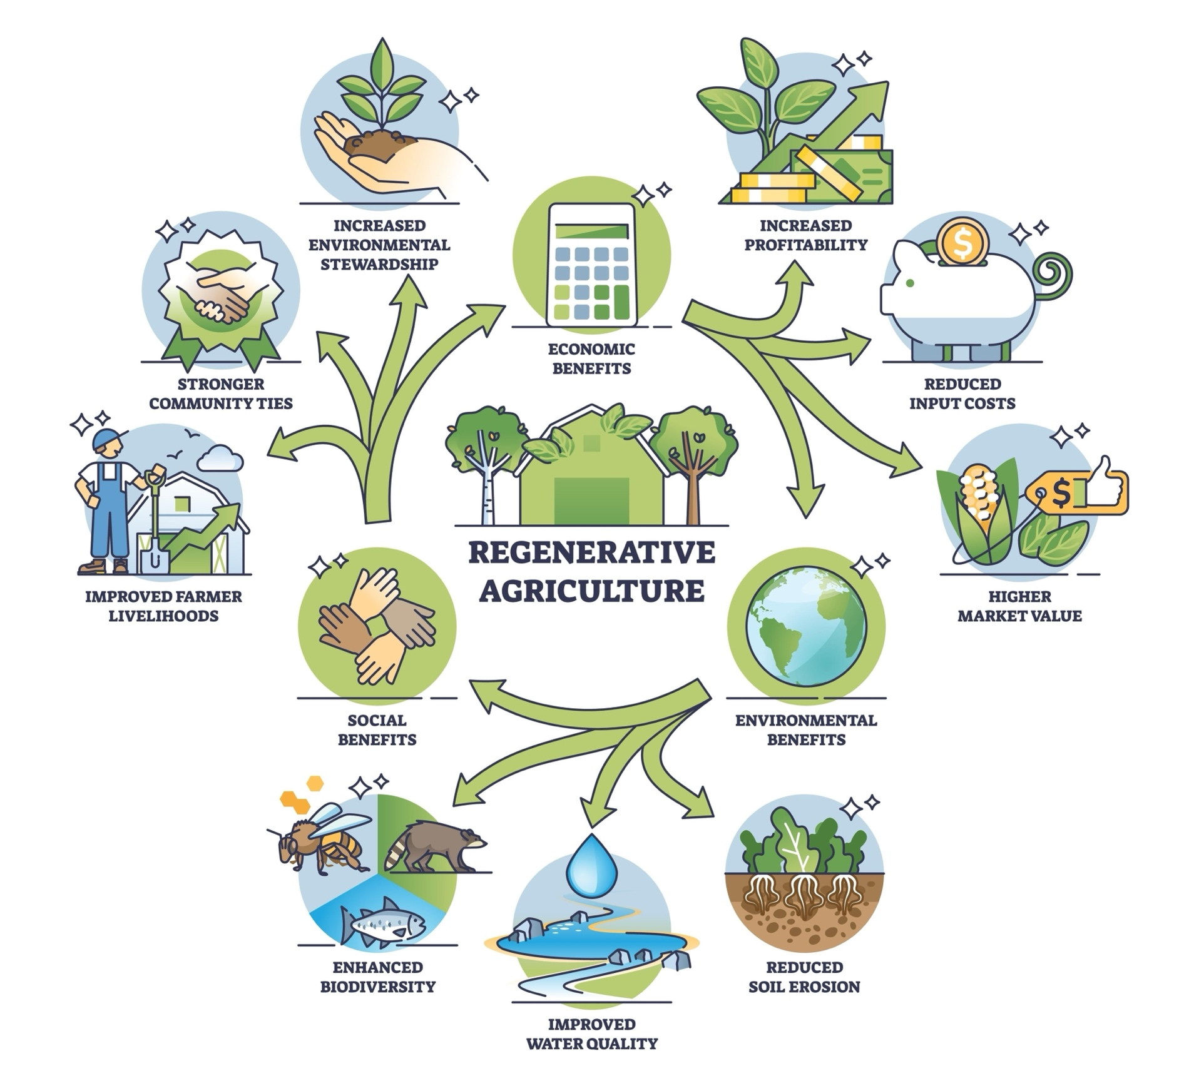
Shutterstock

2. The "RG" Factor (Regenerative Grazing & Growth)
This is the practical application of the vision using the Rives Brothers (RB) and the "Hogs & Cattle" update.
Component | Current State (Conventional) | The "RG" Future (Regenerative)
Soil Cover | Bare soil in winter (Erosion risk). | Living Roots (Cover Crops): Rye/Clover holds soil & feeds cows.
Fertility | Synthetic NPK (Expensive). | Biological (Manure): Cattle/Hogs recycle nutrients naturally.
Livestock | Isolated in a pasture/feedlot. | Integrated: They graze the fields, breaking pest cycles for Klayton.
The Hogs | A risk (rooting/destruction). | The Tiller: Managed correctly, they "till" the topsoil slightly to incorporate seed.

3. Your Potential Future: The 2026 Ecosystem
This is the holistic map of L Cole Farms once the Transition is complete.
- The Hub: Spencer Smith (Manager) sits in the middle, conducting the orchestra.
- The Cycle:
  - Spring: Klayton plants green into cover crops (No-Till).
  - Summer: Crops grow; Spencer monitors drainage/weeds.
  - Fall: Klayton harvests. Yield data goes to Lisa.
  - Winter: Rives Bros move Cattle & Hogs onto the stalks. They eat the residue + cover crops.
  - Result: Free fertility for Klayton; Free feed for Rives. Profit for Lisa.

4. EXECUTION: The "Spencer Script" for Klayton
This is how you bridge the gap between "Idea" and "Reality" using the Marty Travis video.
Scene: Spencer Smith sits down with Klayton at the kitchen table or shop.
Prop: The Lease Addendum (Part 3 of Master Doc) & The Video Link.
Spencer:
"Klayton, before we sign the new lease for '26, Lisa asked me to share this with you. It’s a podcast with Marty Travis [Show Video 107].
You know how hard margins are right now. Marty talks about how the 'Lone Wolf' farmer is going extinct. The future is partnerships.
That’s what this new lease is. It’s not Lisa telling you how to farm; it’s Lisa giving you a partner (The Rives Boys) to lower your fertilizer bill.
- You plant the Rye (We share the cost).
- The Rives Boys graze it (They take the liability).
- You get the manure and the soil health.
We want you here for the long haul, Klayton. But to do that, we have to farm like Marty talks about—regeneratively. Does that make sense?"

